|  |  |
| --- | --- |
| Assignment Date | 25 September 2022 |
| Student Name | ABISH.D.P |
| Student Roll Number | 960519205001 |
| Maximum Marks | 2 Marks |

# Challenge:-

A Upload the dataset to Cognos Analytics, prepare the data, explore and Create Interactive Dashboard.

# Solution:

## LOCATION COLOURED BY SALES?

1. NVERTORY STOCK BY WARE HOUSE? SOLUTION

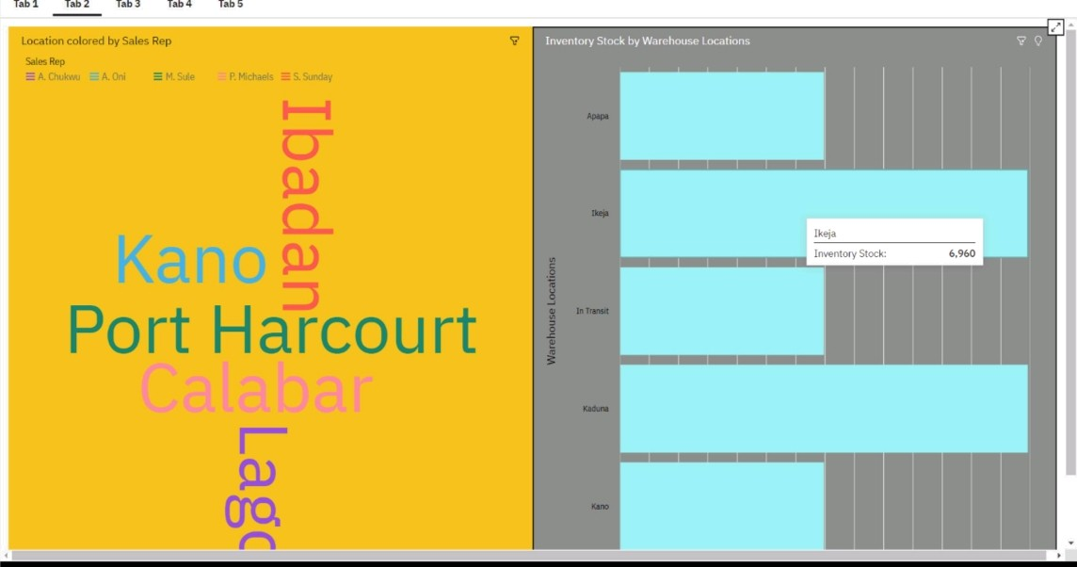

4)SUPPLIER SIZED BY INVENTORY STOCK? SOLUTION

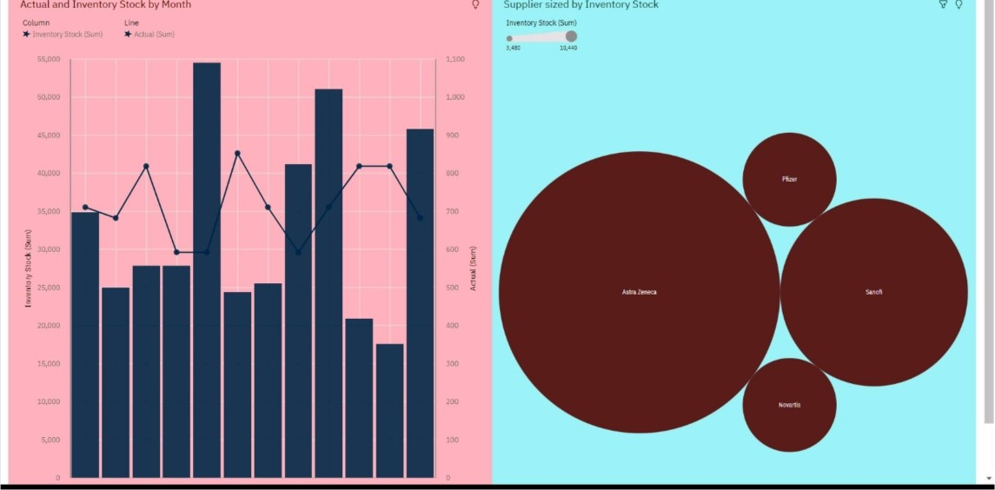

6)SALES BY CUSTOMER? SOLUTION

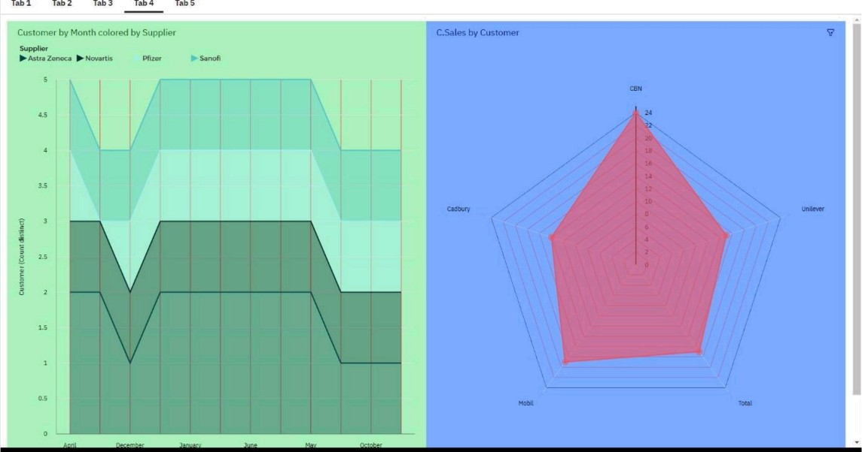

8)TARGET FOR SALES REP? SOLUTION

Tab 2 Tab 2 lab 3 Tab 4 lab S

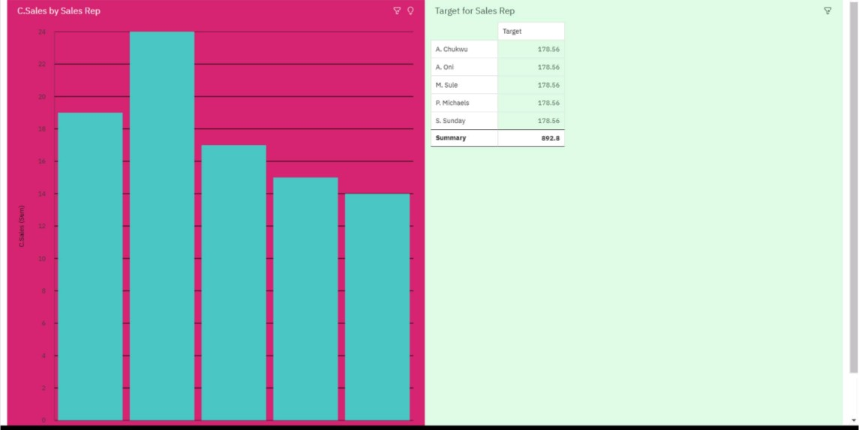

REFERENCE LINK

https://us1.ca.analytics.ibm.cozr;J'bi,/?perspective=dashboard&pathRef=.my_fo lders0/o2FData 0/o2Bmodule 0/o2Fpharmacy 0/o2Bdata&action=view&mode =dashb oard&subView=mode10000018372f0dfa1_00000000